IBCA Asian Individual Chess Championship For The Blind & Visually Impaired – 2026
05 – 15 November 2026

Contents
Welcome Note 2
Invitation 4
1. Dates, location and venue. 4
2. Event program. 4
3. Eligibility to participate; Delegation. 5
4. Technical information and schedule. 5
5. Chess equipment. 5
6. Accommodation & Fee 5
7. Registration fee: 5
8. Registration, Deadlines & Refund Policy. 6
9. Transportation from and to the airport. 6
10. Tournament Head and Additional Arbiters: 6
11. Prizes: 7
12. Visa information: 7
13. Medical insurance: 7
14. Contact information: 7
View of Karachi - The City of Lights 8

Welcome Note
Warm Welcome to Karachi, Pakistan
On behalf of the Pakistan Blind Sports Federation (in collaboration with Pak Christian Foundation)
It is with great pride and heartfelt warmth that we welcome all participating countries to Karachi, Pakistan, for the IBCA Asian Individual Chess Championship for the Blind & Visually Impaired – 2026.
We are honored to host this prestigious event, where remarkable athletes from across Asia come together to celebrate skill, determination, and the unifying spirit of chess. Your presence is a testament to the strength, resilience, and talent of the blind and visually impaired community.
As you compete, explore, and experience the vibrant culture of Karachi, we hope you will feel the hospitality, friendship, and respect that Pakistan extends to each of you. May this championship foster new connections, unforgettable memories, and inspiring achievements for all participants.
We wish every player the very best of luck and an enjoyable stay in our beautiful country.
Welcome to Pakistan
Pakistan Blind Sports Federation (in collaboration with Pak Christian Foundation)

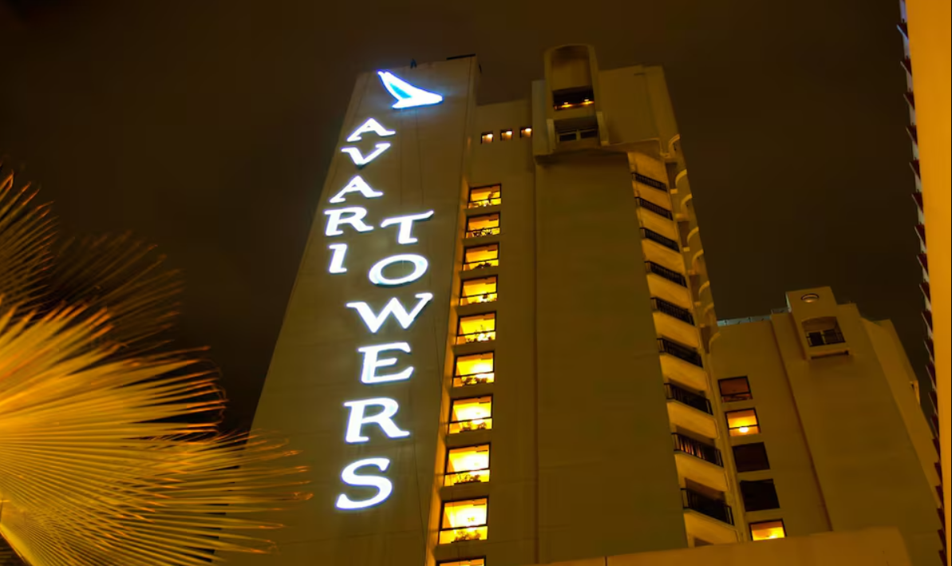

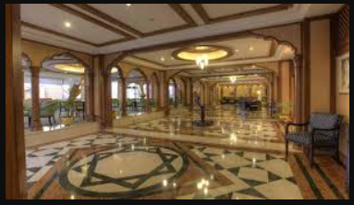

Invitation

Pakistan Blind Sports Federation (in collaboration with Pak Christian Foundation) and The International Braille Chess Association (IBCA) have a great pleasure to invite to the IBCA Asian Individual Chess Championship For The Blind & Visually Impaired – 2026

Dates, location and venue.
IBCA Asian Individual Chess Championship For The Blind & Visually Impaired 2026 will be held in Pakistan (Karachi) from 05th November to 15th November 2026.

Event program.
Date of Arrival: 05th November 2026
Round 1: 6th November 2026
Round 2: 07th November 2026
Round 3: 8th November 2026
Round 4: 9th November 2026
Round 5: 10th November 2026
Round 6: 11th November 2026
Round 7: 12th November 2026
Round 8: 13th November 2026
Round 9: 14th November 2026
Date of Departure: 15th November 2026

Eligibility to participate; Delegation.
It is open to all IBCA Asian member countries, every eligible organization can register any number of players of any gender.

Technical information and schedule.
The tournament will be held under the official IBCA and FIDE rules as a nine-round, Swiss system event, with one (1) round per day from 05th to 15th November 2026. Time control – 120 minutes + 30 seconds increment per move.

Chess equipment.
All games in the tournaments will be played only on Braille Board. The organizer will provide Echo DGT clocks.

Accommodation & Fee
Venue: Avari Towers Karachi, Hotel
https://avari.com/avari-towers-karachi/
Price/person with full board (three meals/day):
Room type: Price:
Double room per person/day 50 euro
Single room per person/day 80 euro
For security reasons, all members of the delegations, including players, coaches and accompanying persons, shall stay in the official hotel (Avari Towers Karachi, Hotel). The Organizing Committee will not accept any person who does not book rooms in the official hotel. Only the Organizing Committee is in charge of all hotel registration. All accommodations requests shall go through the Organizing Committee.

Registration fee:
60 Euro per participant (includes the Organizer Fee of 30 euro and the IBCA entry Fee of 30 euro).
All delegations must pay a full Registration Fee + a deposit equal to 50% of the total cost for accommodation, no later than 01st September 2026.
Account details are mentioned below:
Bank Name: United Bank Limited
Title: PAK Christian Foundation
IBAN. PK87UNIL0109000340998164
SWIFT Code: UNILPKKA933

Registration, Deadlines & Refund Policy.
The following deadlines shall be respected:
To register the participants including full registration fee: no later than: 15 July 2026
Participants whose fees are not received by 15 July 2026 will not be considered for the participation.
50% deposit: no later than: 25 August2026
To submit last 50% of payment: no later than: 15 September 2026
To submit flight details: no later than: 30 September 2026
Refund Policy:
- Registration Fee
Registration Fee is non - refundable.
- Advance Deposit Refunds
- For refund requests made on or before 10 September 2026, 50% of the advance deposit will be refunded.
- For refund requests made between 11 September 2026 and 20 September 2026, 30% of the advance deposit will be refunded.

Transportation from and to the airport.
Organizer will provide transportation for all participants from/to the Jinnah International Airport Karachi. All delegation must send their flight details (dates, times and flight numbers for arrival/departure) to the Organizing Committee, no later than 25 September 2025.

Tournament Head and Additional Arbiters:
The Organizer will appoint the IBCA Head and arrange Additional Arbiters from Chess Federation of Pakistan.

Prizes:
The players who will win the championships will be declared accordingly the 2026 IBCA Asian Individual Chess Champion and will be awarded a trophy. Second and third places will also be awarded with trophies.

Visa information:
Players and other delegation members who need visa to enter Pakistan, are requested to contact the Organizer before 01 June 2026.

Medical insurance:
All persons who are part of the delegations of the participating countries must have medical insurance. The organizer will not provide any payment regarding a possible medical problem.

Contact information:
Local Organizing Committee: Pakistan Blind Sports Federation (in collaboration with Pak Christian Foundation)
Contact Person: Mr. Muhammad Waqas Waraich (Phone: +923009621060)
Contact Person: Mr. Ajeet Kumar (Phone: +923368261643)
Contact Person: Mr. Tariq Samuel
Email: blindsportspk@gmail.com
URL: http://www.pbsf.org.pk

View of Karachi - The City of Lights
